Project Development Phase
Model Performance Test

Date | 08 October 2026
Team ID | 9100Byte
Project Name | Implement Client Script & UI Policy (Incident)
Maximum Marks | As per evaluation

Model Performance Testing:
Project team shall fill the following information in model performance testing template.
S.No. | Parameter | Values | Screenshot
1. | Configuration Summary | UI Policy: High Impact Control. Client Scripts: Auto set urgency for high impact; Prevent save if Assigned To missing; Prevent state change via list edit. | 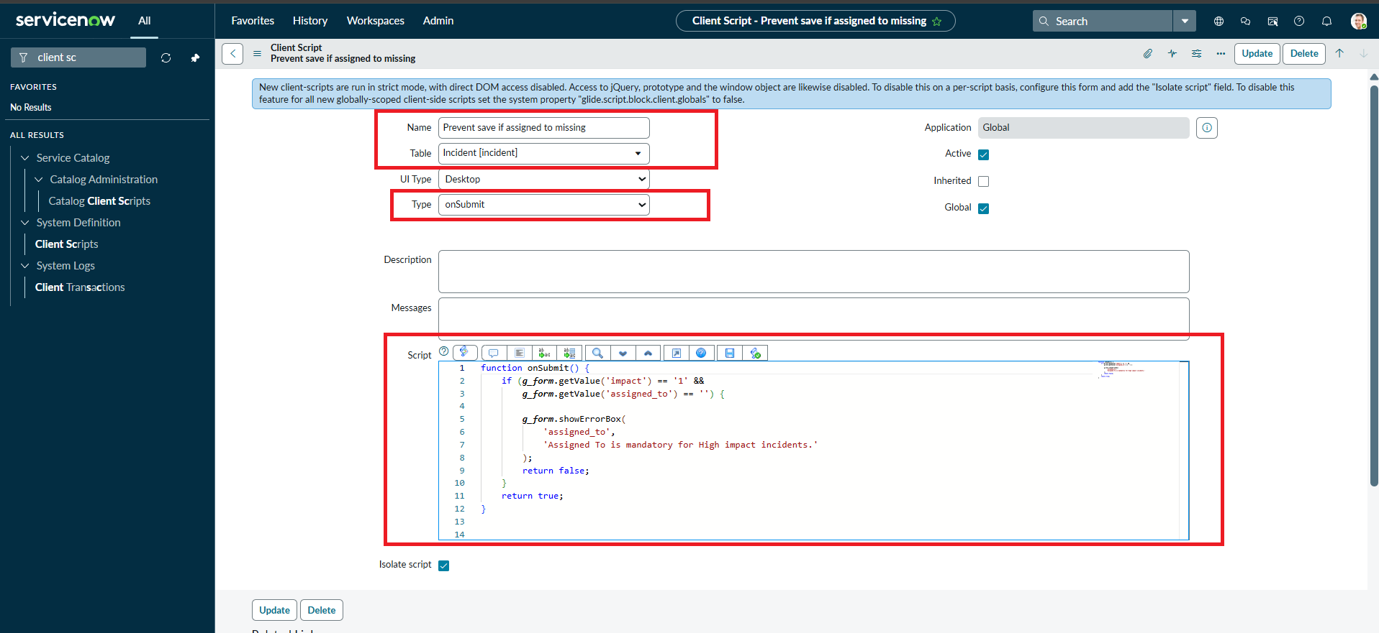
2. | Functional Accuracy | High Impact triggers mandatory Assignment group and read-only Urgency. onChange sets Urgency High. onSubmit blocks missing Assigned To. onCellEdit rejects direct State list changes. | 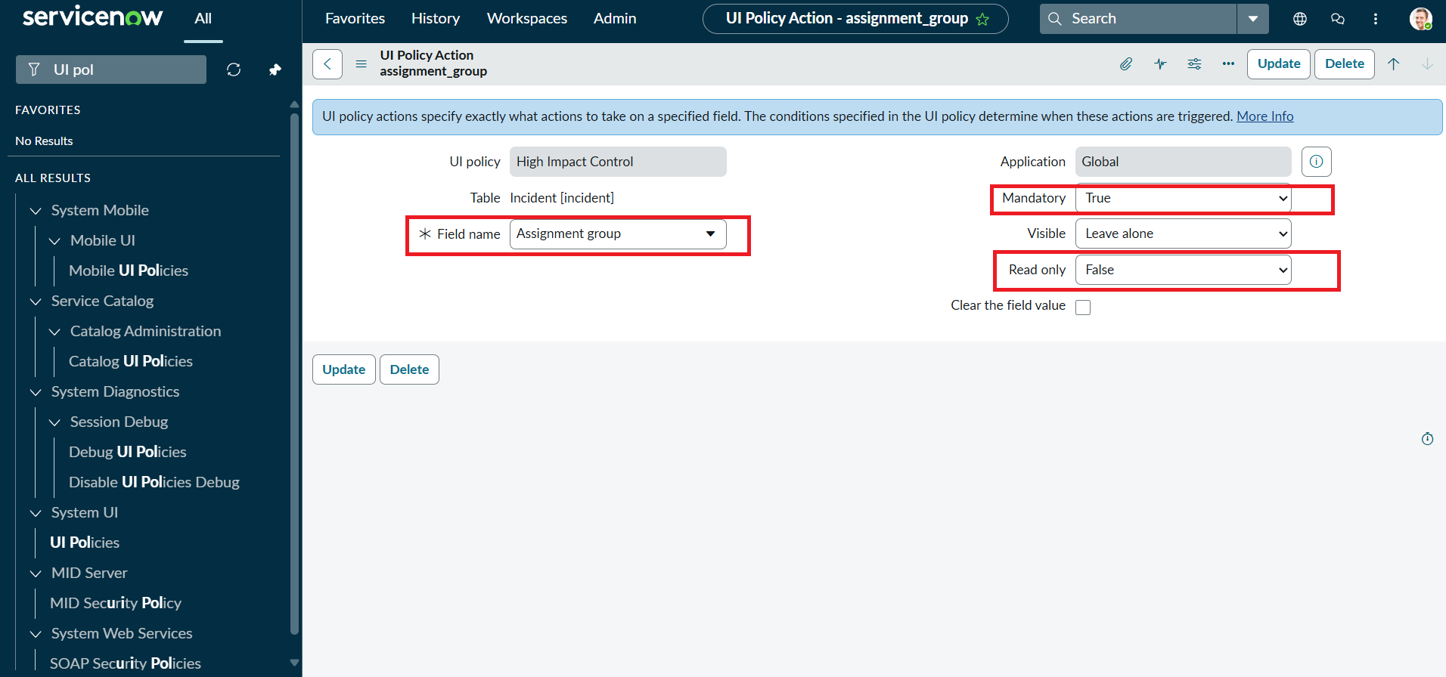
3. | Fine Tuning / Rule Refinement | No AI model fine-tuning is involved. Refinement consists of verifying conditions, field behavior, error handling and condition reversal. | 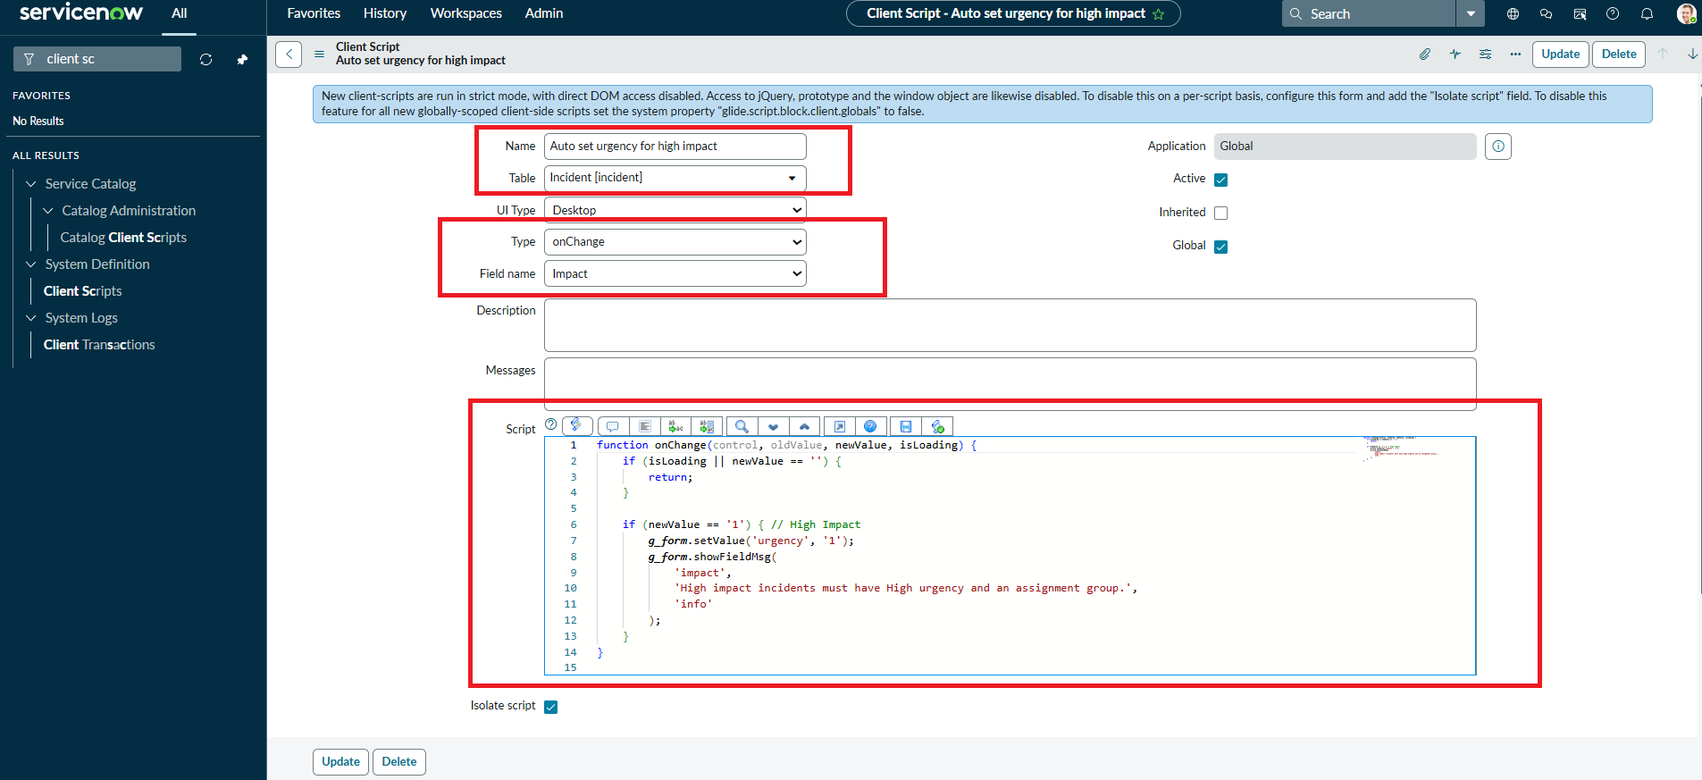

Execution Result Summary
Overall Result: PASS – implementation behavior is evidenced by the supplied ServiceNow screenshots and project document.
UAT Result: PASS – all listed functional scenarios are documented as successfully configured/verified.
Defects: None identified in the supplied evidence.
Evidence Status: Existing screenshots from the submitted implementation document have been retained and reused.
Project: Implement Client Script & UI Policy (Incident) | Team: 9100Byte | Date: 08 October 2026
Note: No AI model or training process is claimed for this ServiceNow configuration project. The template is filled with the actual rule/configuration evidence supplied.
Configuration Evidence
Evidence: Supplied ServiceNow implementation screenshot(s).
image7.png
image3.png
image6.png

